Contents of table

1. Overview 2

2. Architecture 3

3. UI 4

3.1. Main Screen 4

3.2. User Management 7

3.3. History Management 7

3.4. Function Test Case 9

# Overview

This document describes the overall architecture & detail design of ECG Mobile App insisted of Client side & Server side(aims at testing) which has following basic features:

ECG Chart related:

1) receive data from remote client side, display it simultaneously, and save it to a database

2) discover target devices around, connect it, sending original ECG data(currently the simplest double type)

3) generate a ECG chart from database for displaying history ECG records of user

All the ECG charts are capable of auto-adjusting when adding/removing under-layer data, and scaling , dragging when user interacts with them, also support multiple plots in a single chart.

User Management related:

1) list available users in system & query their details information

2) add/delete a specific user

3) query history records of a specified user

# Architecture

The following diagram is the block diagram of ECG Mobile app:

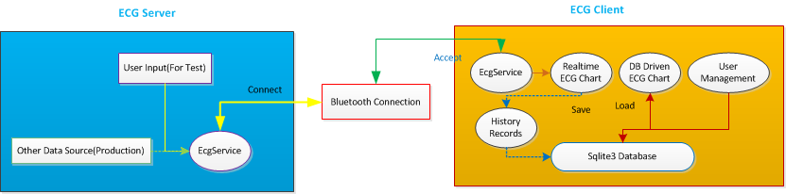

ECG Server communicates with each other with the help of EcgService which is consisted of some threads for connecting target device and also for accept remote requests from other devices.

On ECG Client mainly relies on the under-layer sqlite3 database, now will details it:

1. The User management  
   all the user’s info in the system is stored at {EXTERNAL_STORAGE}/ecg/user.sqlite(usually the “EXTERNAL_STORAGE” is /sdcard, aka /mnt/sdcard/), all the history records of a unique user is saved as a database, and every record is saved as a table whose name is the system time when user selecting “save” command.
2. Displaying history records  
   when user selects a valid user in the system, he/she can select one of her past records to look. At this time the app internally constructs a JDBC database driven PlotView to retrieve data from database and render it.

# UI

## Main Screen

1. Client side:

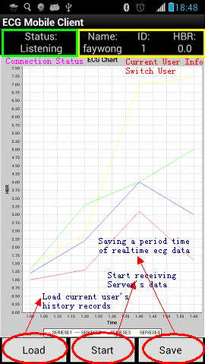

1. Server side

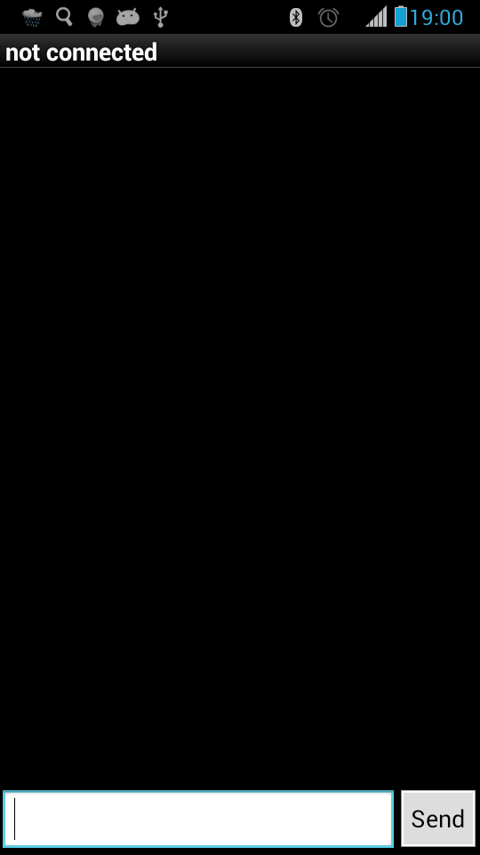

Server side main screen

Connect a target device from server side(press “menu”):

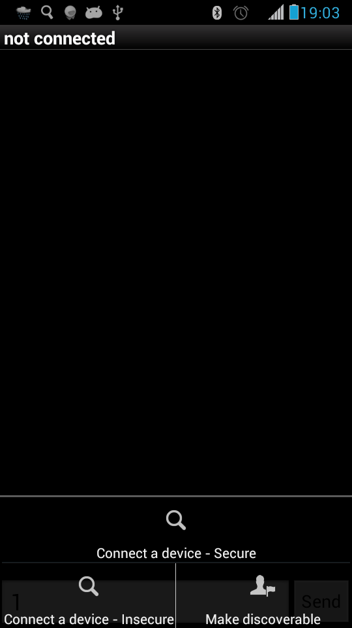

Server side connecting a target device

## User Management

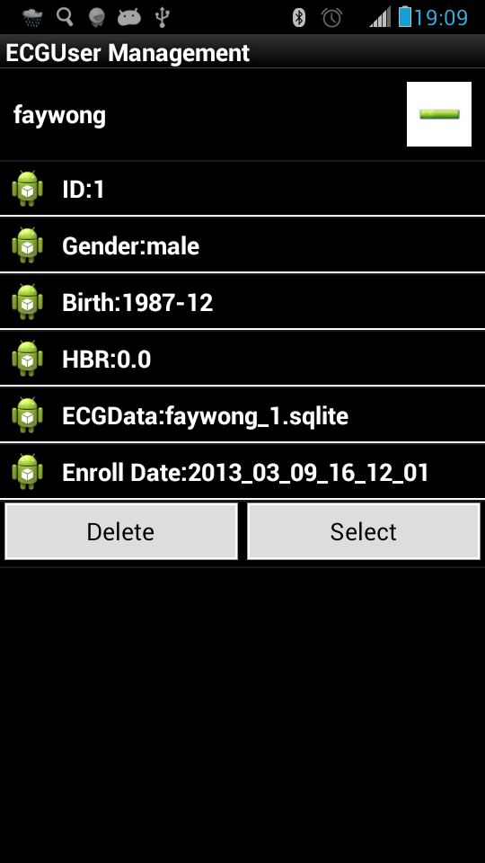

List available users

In this page, you can delete the user or select it as the system’s current user.

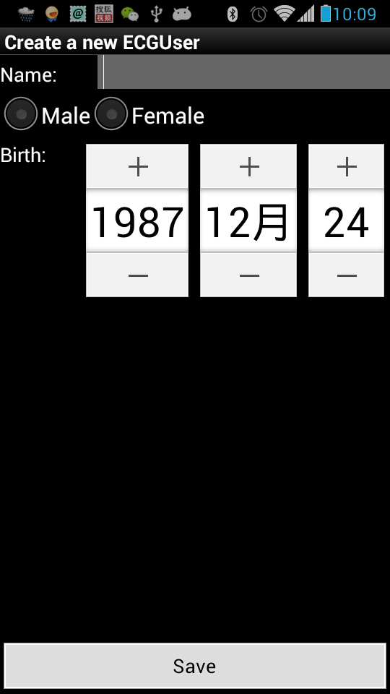

Create a new user

In this page you can register a new user into system.

## History Management

List and Select a history record of a specific user:

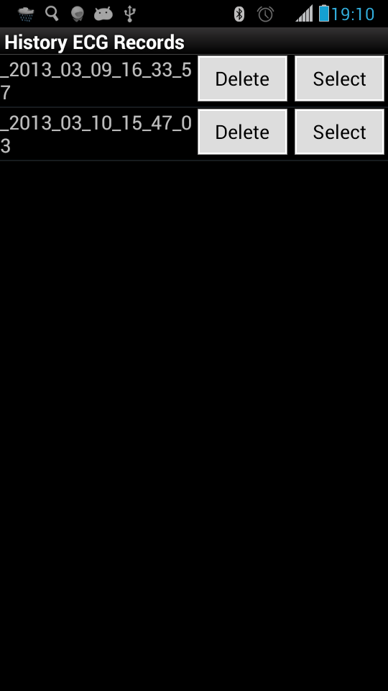

One of sample history record is as following:

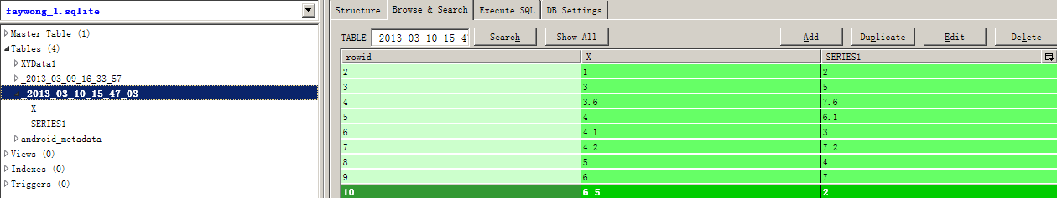

And the corresponding plot is:  
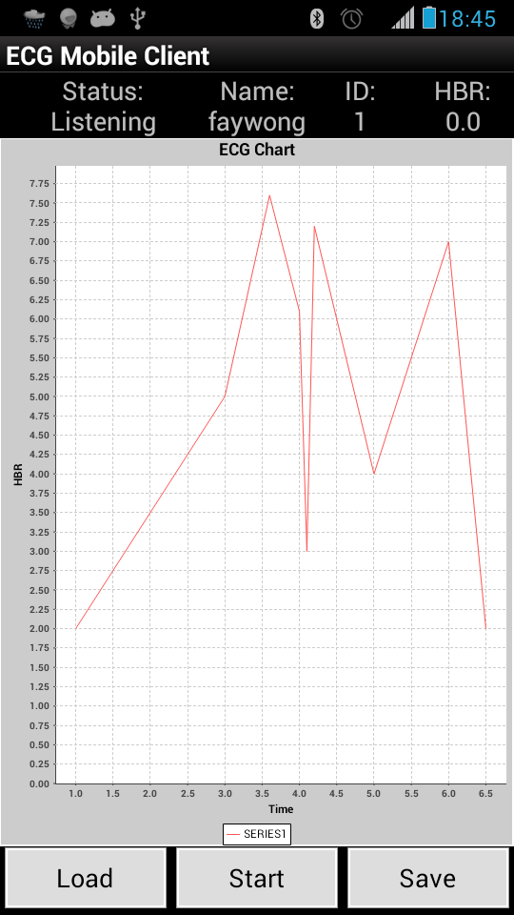

## Function Test Case

Pre-request:

Android Phone A & B(prefer android 4.x) shipped with Bluetooth feature

Test steps:

1) Launch ECG Mobile Client on Phone A, press menu --> make discoverable

2) Launch ECG Mobile Server on Phone B, press menu -->

Connect a device insecure --> Scan for devices

if any device found, press on it to connect it.

3) Once connected successfully, press “start” on Phone A

3) Then input "123.0" in Phone B, and press "Send" button to send it out

4) Verify on the Phone A whether a Toast popped out and says "Received a msg with a double type data:xxxx", and the plot view rendered a point.

5) Loop multi-times of step 3) 🡪 step 4)